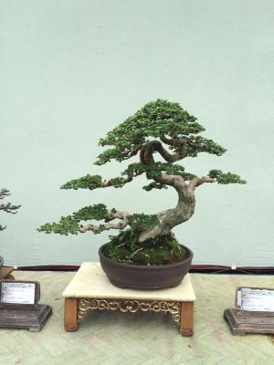

Scientific name: Cedar Bonsai

LIGHT:

Your cedar bonsai will prefer indirect sun and requires at least 6-hours a day of sunlight. If you can furnish it with more, all the better.

.

WATERING:

During the growing season you will usually be watering your bonsai daily. Allow the plant to get nearly dry before watering. Do not let it completely dry out. If the leaves turn yellow, it is a sign you are giving your bonsai too much water

SOIL:

The appropriate soil for the cedar bonsai is a mix made with mostly inorganic aggregates. Cedar trees prefer acidic soil so the addition of the pine bark mulch will add to the acidity while providing some organics to nourish your plant.

FERTILIZING:

Your cedar bonsai will have very little soil. There are little, if any, organics to draw nutrients from, so it is necessary to replenish the trees nutrients occasionally.

Any multi-purpose liquid [fertilizer](https://www.thespruce.com/how-to-fertilize-houseplants-1902846) available at your friendly local nursery or garden center can be used for this purpose. For the cedar bonsai, remember to dilute the mixture by fifty percent with water before applying and apply every two weeks.

### Temperature and Humidity:

Cedars grow naturally in mountainous terrain from the Mediterranean to the Himalayas. This bonsai will tolerate some cold and moderate heat but does not thrive in high humidity.